User instruction for smFISH analysis 3.10

Part1: Instructions on How to set up python environment.
Please refer to https://github.com/stardist/stardist for stardist instruction
and https://big-fish.readthedocs.io/en/stable/ for fishquant instruction
Install anaconda from any distribution from ananocda website.
https://www.anaconda.com/docs/getting-started/anaconda/install
For Any mac user using apple silicon (see Q&A 1 if you are not sure).
Open terminal.
Run the following code to install command line tools
xcode-select –install
Run the following code to setup environment and set up stardist and big-fish/fish-quant
conda create -n stardist-env -c conda-forge python numpy scipy cython \
joblib threadpoolctl pytest compilers llvm-openmp meson-python ninja
conda activate stardist-env
conda install -c apple tensorflow-deps
pip install tensorflow-macos tensorflow-metal
pip install stardist
pip install big-fish
Use the following code:
pip list | grep tensorflow
pip show tensorflow-metal
Get your tensorflow and tensorflow metal version.
Check on this following website to see if your tensorflow is compatible with tensorflow metal and your macOS operation system.
https://pypi.org/project/tensorflow-metal/

For other platform users:
Just set up your environment normally with with the instruction and pip install.

Part2: Installation of jupyter notebooks/jupyter lab and set up python interpreter

Use the following code:
conda activate stardist-env
python -m pip install ipykernel
python -m ipykernel install --user --name=myenv --display-name "smFISHanalysis-env"

Then run jupyter lab by just typing jupyter lab, or notebook.
When running any of the code, set the kernel to smFISHanalysis-env.

Part3: Data Structure, pre-processing
Usually I will do data pre-processing, mostly rotate image if needed, to make them correctly oriented. Also regions obviously does not express anything, or z-stack that does not contain any expression profile will be removed by using ImageJ. I will select region of interest, and add to ROI manager and save it within the same folder.
I will split all channels and save them as separate z-stacks.
It is usually: Experiment number -> control/experiment -> condition -> channel.
For example, Experiment 304 -> experiment -> 0h_Ampuation -> Image1 -> 565
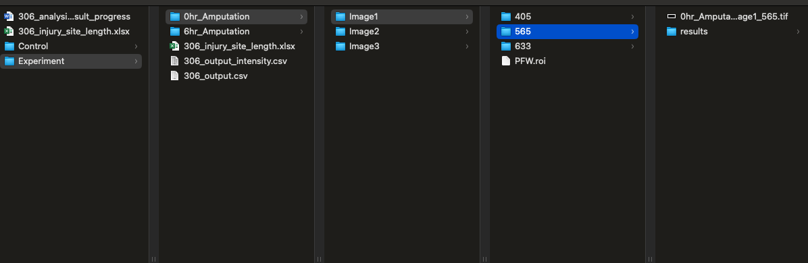

Part 4: Preparing to run the code and Setting parameters
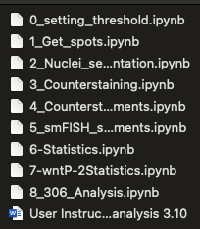
Here each steps is in order, run order is 0 – 1 -2 -3 -4 -5 -6
7 and 8 are specific analysis I did to specific experiment.
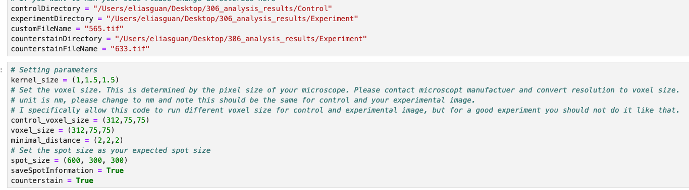

Q&A:
- How do I know if I am using a M series chip or apple silicon?
If you have a M series chip, this can be found on the top left corner click apple icon, click about and if the first line chip starts with Apple M1/2/3/4 or any other number)

